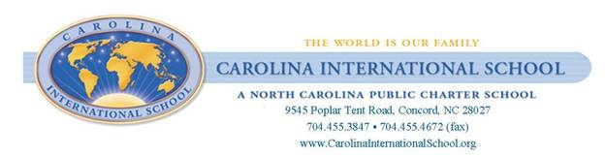
August 15, 2016

Dear Parent or Guardian,
In an effort to ensure that the unique needs of students with immediate family members in the military are met, Session Law 2011-185 (and subsequent modifications in Session Law 2012-194) requires the North Carolina State Board of Education/ North Carolina Department of Public Instruction to report specific information to the General Assembly by November 15, 2015.
This report to the General Assembly is a one-time report. The section of Session Law 2012-194 that describes this report can be accessed at: http//www.ncleg.net/Sessions/2011/Bills/Senate/PDF/S847v6.pdf, beginning at the bottom of Page 22. Your school guidance department can provide a hard copy of the applicable part of the law.
To ensure compliance with Session Law 2012-194 please complete the following information.
Has an immediate family member of your child served in the U.S. Military (including the National Guard and the Reserves) since September 1, 2001?
“Immediate family member” is defined as a parent guardian, grandparent, sibling, step-parent, aunt, or uncle.
______________ Yes ________________No
Student’s name: ______________________________________________________________ (Please return a separate form for each child in your household who attends school at CIS)

The Department of Public Instruction will assist the district in providing training to school staff that supports our military students.
Please return this form to your child’s homeroom teacher by August 26, 2016
If you have any questions, please call to the school and ask for an administrator at 704-455-3847

Sincerely,
Carolina International School’s Administrative Team

